# Bootstrap Worksheet

Research and code the following. Evidence your work with a screenshot or two and with a folder of your code ready for me to take a look at. You should have a website with a folder of work. In that folder make sure you have an index.php page with links to all work you produce.

Things you must have:

* index.php with links
* Screenshots of work in desktop mode
* Screenshots of work in mobile mode
* Annotated code

# 1

CDN – research the difference between hosting bootstrap on your website vs pulling it in via a CDN such as “maxcdn.bootstrapcdn.com”

# 2

What are the most popular css CDNs, find the pros and cons of each.

# 3

Does bootstrap require any javascript libraries to work?

# 4

Look at the bootstrap downloads page. It mentions that the files are compiled and minified. What does this mean? Why are they doing this?

# 5

Research:

* Layout -> Breakpoints
* Layout -> Containers

Using containers create a webpage with a grid layout. Top row has 6 elements, bottom row has 3 elements. Use borders, padding and margins to show the layout in a pleasing way.

# 6

There are two ways to construct grids in bootstrap:

* Layout -> grid
* Layout -> CSS Grid

CSS Grid lists the reasons of why both why both exist. CSS Grid is probably a better option to learn for modern web design.

Using CSS Grid construct a web page that has this layout:

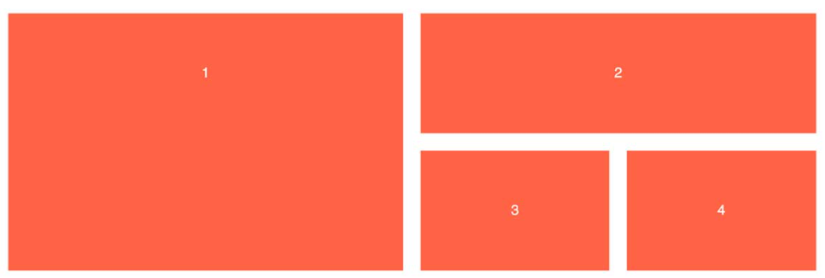

And then below it this:

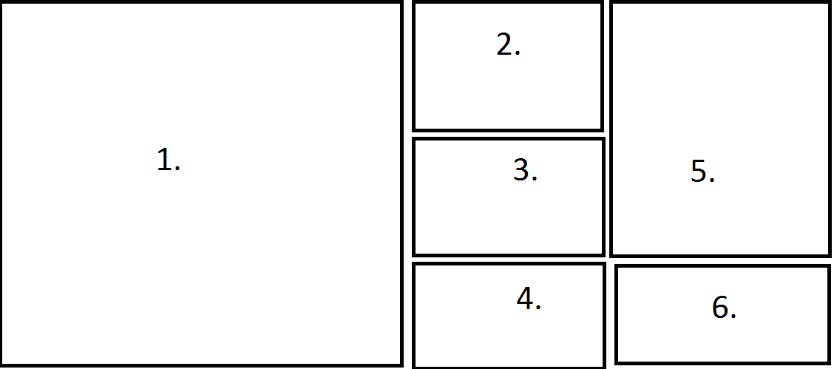

# 7

Create a webpage that has a navigation bar. Ensure that it collapses correctly for mobile:

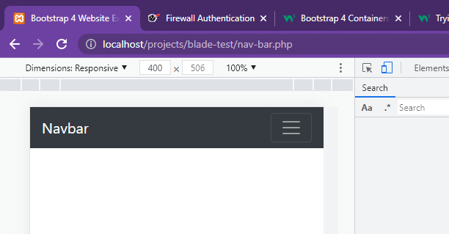

# 7.5

Complete the simple me template in bootstrap 5:

<https://www.w3schools.com/bootstrap/bootstrap_theme_me.asp>

and do the band one

<https://www.w3schools.com/bootstrap/bootstrap_theme_band.asp>

# 8

Create the following user info card (bootstrap -> components -> card)

Note: border, rounded corners, background colour a light grey.

https://getbootstrap.com/docs/4.0/utilities/borders/

The profile image has a negative top and bottom. This is how the styles were applied to create the offset.

No style:

The image is inside a div.

Image border radius set to 50%

This shows the div that contains the image. Alter the div style to be:

This moves the div and image up negative 50px, the margin bottom pulls the content below up 50px removing any weird whitespace left.



Set the image border to be transparent, 5px solid white.

The bottom links:

Are anchors with the button class set (e.g. class="btn btn-primary" which makes it blue). Then a 50% border radius to make them round. The icons come from https://fontawesome.com/ for a tutorial on how to use them:

<https://fontawesome.com/v5.15/how-to-use/on-the-web/referencing-icons/basic-use>

# 9

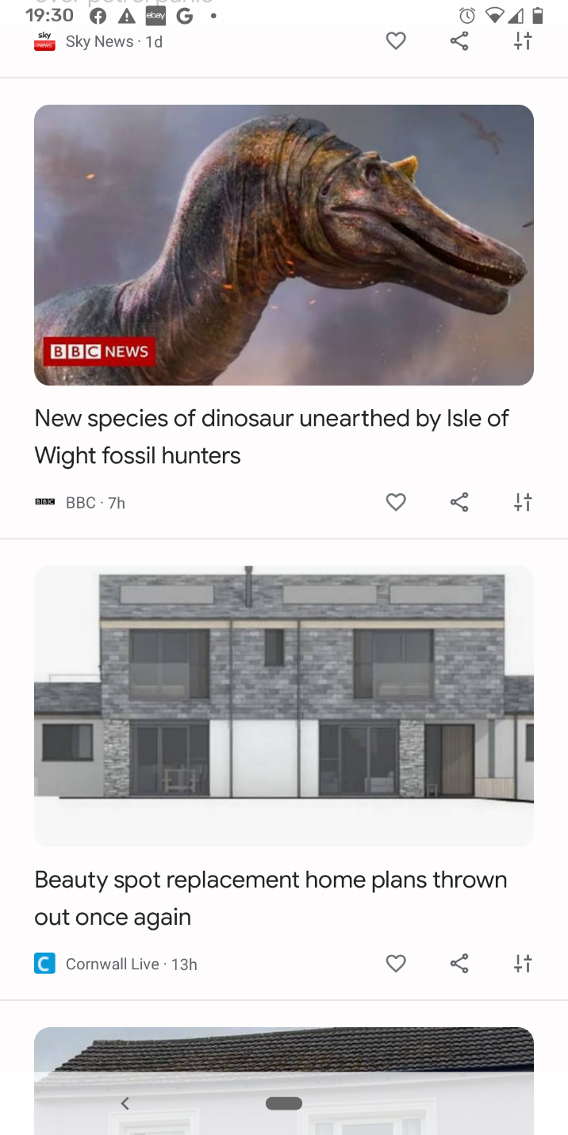

Create a template for the above. Image, title, Link, 3 icons, Like, share and preferences.